SCREENSHOTS OF THE REQUIRED ENDPOINTS FROM POSTMAN

1. User Registration Endpoint  
   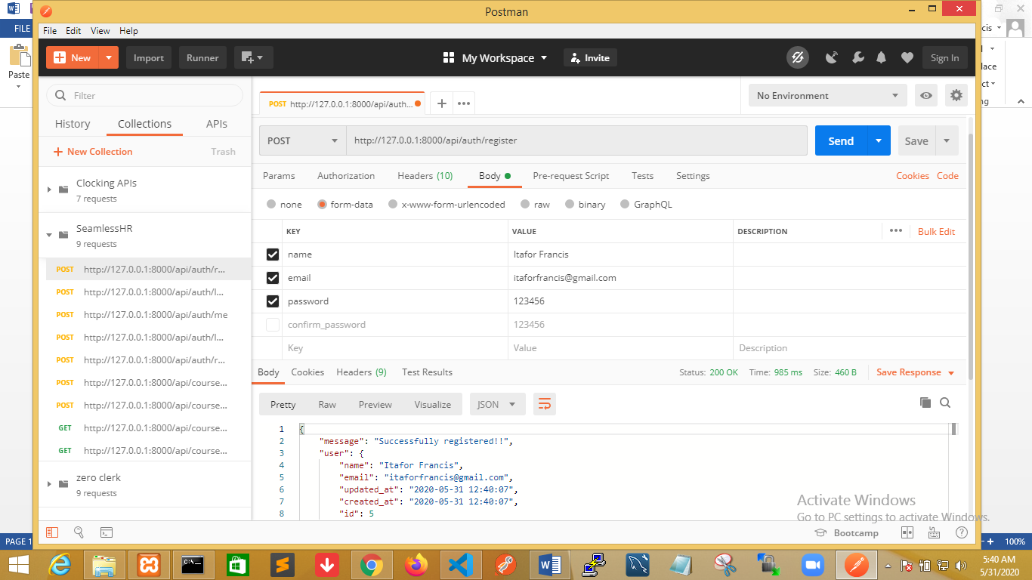
2. User Login Endpoint  
   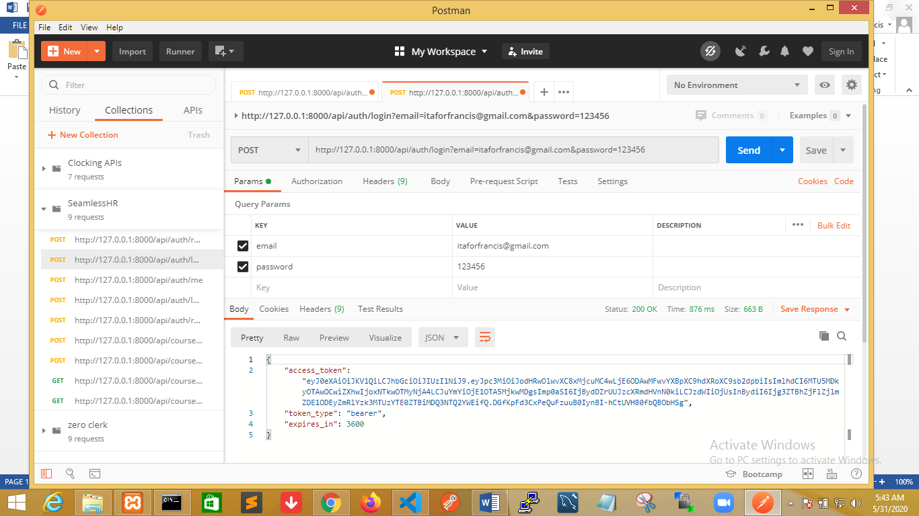
3. Endpoint to create 50 courses by calling a course factory  
     
   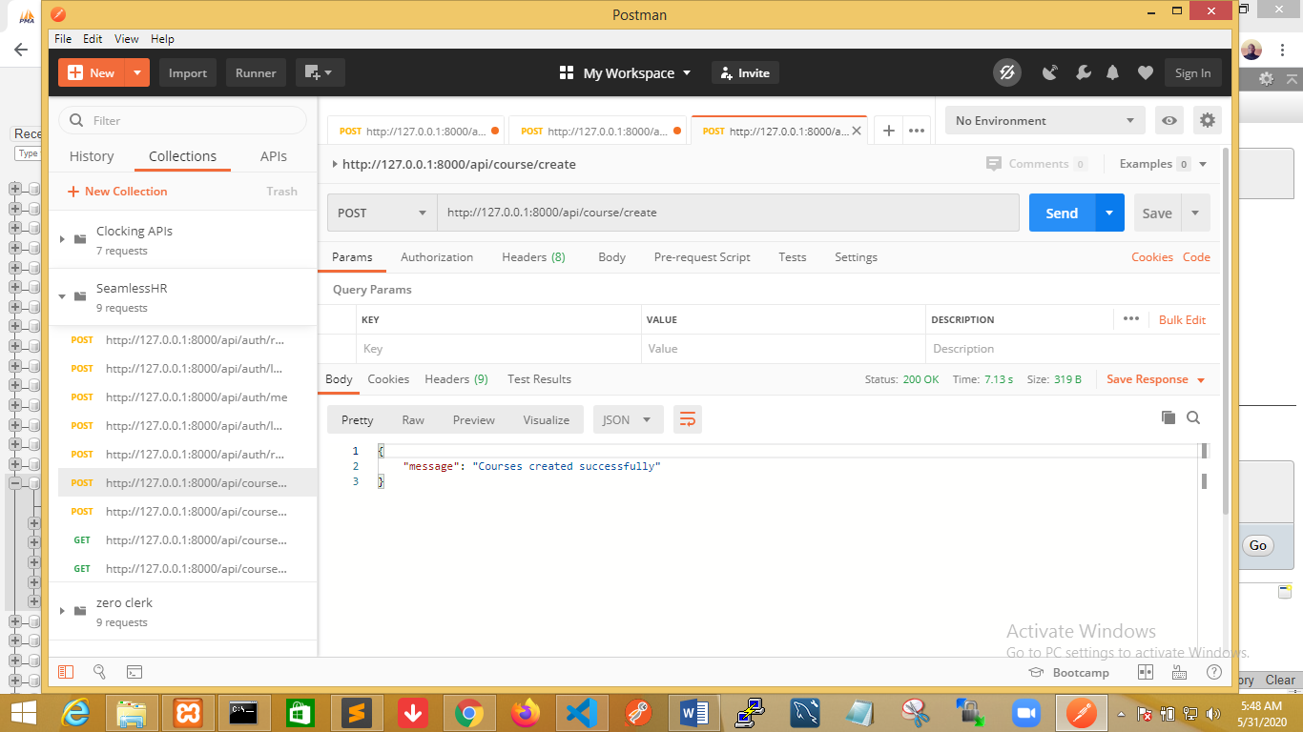
4. Course(s) Registration Endpoint  
   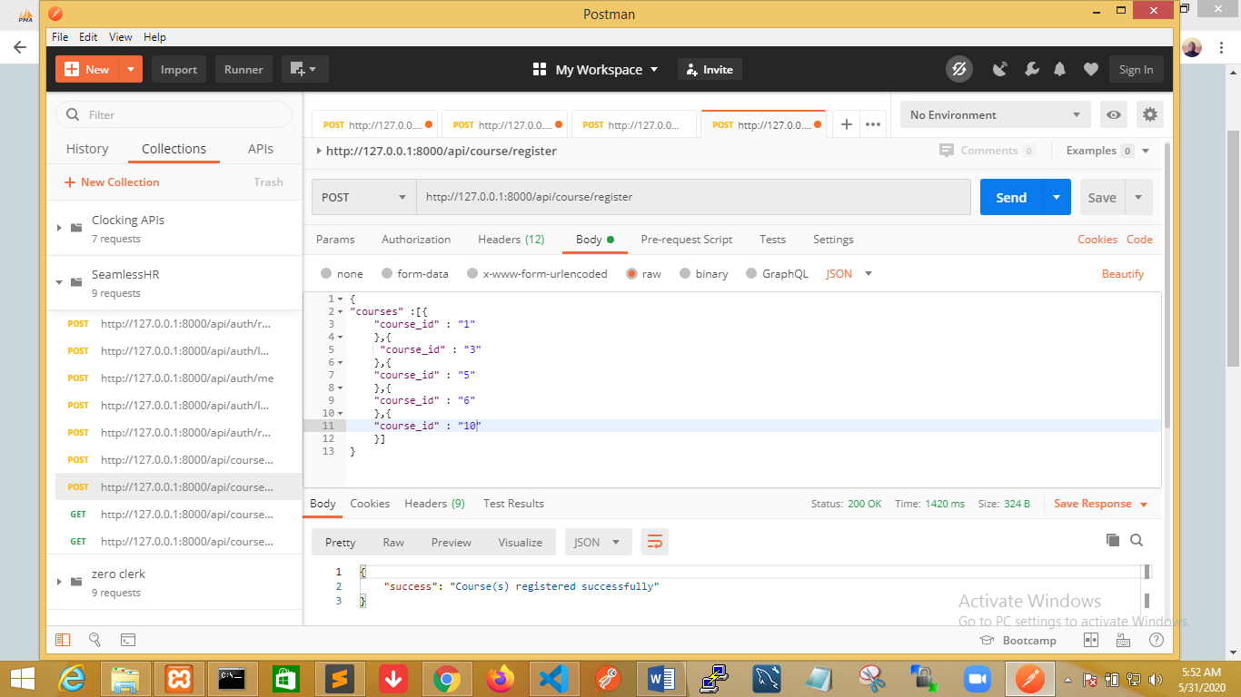
5. Endpoint to list all courses with user’s enrollment date  
     
   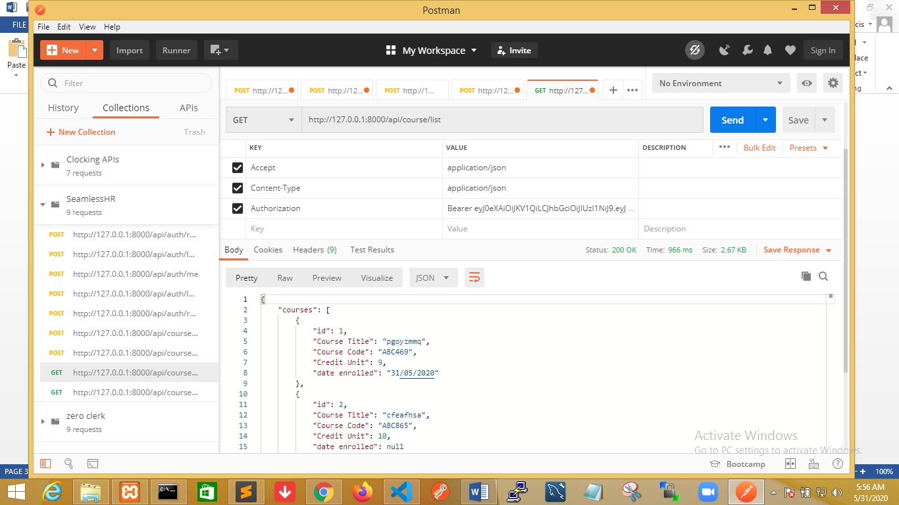
6. Endpoint to export all courses using the maatexcel package  
   